Knowledge, Attitude and Practice &
Initial Baseline Indicator Report for
Slaeng Spean Water and Sanitation Project

Prepared for Water For Cambodia
With Funding from Rotary Club of Bath, Maine, USA and Rotary District 7780

Nov. 2014

Prepared by Kristen Davies




Acknowledgements

The author gratefully acknowledges the assistance of Nthabeleng Emmel (Water for Cambodia) and Rich Cromwell (Rotary Club of Bath) for guidance, input and support during the course of the survey. Special thanks are extended to Seang Seur, Kong Hun, Chhe Sophoan, Seang Phalleap, Pan Sros, and Sin Sisovann for field work.

Table of Contents

1. Objective of Report 5
2. Background of Project Design 6
2.1. Indicators 6
3. Methodology 10
3.1. Report Structure 10
3.2. Village selection 10
3.3. Sample size selection 11
3.4. Respondent Selection 12
4. Water Access and Contamination 13
4.1. Water source 13
4.2. Water storage 14
5. Latrine Access and Sanitation 19
6. Health and Social Impacts 23
7. Discussion and recommendations 27

Tables of Figures

Figure 1 Initial Project Concept 7
Figure 2 Project goals, objectives, indicator data, and baseline results 8
Figure 3 Household response by village 11
Figure 4 Breakdown of IDPoor respondent households of all villages surveyed: 12
Figure 5 IDPoor breakdown of all respondent households by village: 12
Figure 6 Total male and female response was: 12
Figure 7 Main source of drinking water in wet season 13
Figure 8 Main source of drinking water in dry season 13
Figure 9 Minutes walking to water source, by season (round trip) 14
Figure 10 Percent of households covering all water storage jars 14
Figure 11 Level of cleanliness of water storage containers (n=105) 15
Figure 12 Percent of households treating drinking water 15
Figure 13 Type of water treatment, by village 16
Figure 14 Reasons households who treat their drinking water (n=36) do so 16
Figure 15 Percent of HH respondents the have had diarrhea comparing all HH with HH that treat drinking water 17
Figure 16 Percent of households with water filters 17
Figure 17 Key times for hand-washing 18
Figure 18 Percent of respondents washing with water only and water and soap 18
Figure 19 Percent of HH with fixed hand-washing stations that have soap (n=14) 18
Figure 20 Importance of hand-washing 19
Figure 22 Methods of dealing with full latrine (n=21) 20
Figure 23 Latrine flooding situation 21
Figure 24 Location of defecation 21
Figure 25 Household perception of advantages of latrines 21
Figure 26 Encouraging latrines in villages 22
Figure 27 Main health issue faced by household; N-108 23
Figure 28 Rates of diarrhea and urinary tract infections (last two weeks) (total of all households’ members of respondents) 24
Figure 29 Average number of days children miss school for diarrhea / urinary tract infections 25
Figure 30 Average number of days adults miss work for diarrhea / urinary tract infections 25
Figure 31 Medical attention for diarrhea / urinary tract infections 26
Figure 32 Average spending on treating urinary tract infections and diarrhea in last 12 months 26
Figure 33 Prevention of diarrhea 27

Annex 1 Village level demographics

Annex 2 Village water source, well, filter and latrine situation; critical needs and improvements needed

Annex 3 – IDPoor by Village (Survey Respondents)

- Objective of Report

The Bath chapter of Rotary International will apply for a global grant towards water and sanitation activities to be carried out in Srei Snam District in 2015. The report is support of the objective of the Springboard Grant to collect data for the Global Grant. It is envisioned that under the Global Grant Water for Cambodia will implement water filter distribution, and may partner with other organizations to carry out other water and sanitation activities. The Rotary approach is to address underlying causes as part of the solution.

Srei Snam has been previously identified through discussion with the District Governor as having a high need for access to water and latrines to achieve better health outcomes. A few communes were identified through this meeting and Slaeng Spean Commune stood out among the rest as the most in need. Within this Commune, five villages were then identified by the Commune Chief as having a particular need due to both lack of resources and lack of other NGOs operating in the area. These five villages are not currently covered by Malteser International or Plan organizations which are currently working in the area to support water and sanitation activities.

The grant will likely be applied to one or two villages to ensure a high level of coverage, with the potential to scale up to further villages in the future. The objective of the report is to assess the knowledge, attitude, and practices of the villagers in regards to water and sanitation in order to determine the project approach, and to the degree possible, collect indicator data for a baseline on the villages’ situation, and make it possible to measure results and impacts.

Indicators can be found in section 2.1, and summary of findings and recommendations can be found in section 7.

- Background of Project Design

An initial conceptual design was created through identifying the target condition (people have adequate access to clean water and sanitation), and identifying threats to the target condition (water pollution at the source, water pollution at point of use, lack of wells, lack of latrines, lack of water filters, spread of waterborne diseases, and flooding affecting wells and latrines). Water pollution at the source includes pollutants in ponds, rivers and streams and well (stemming from a variety of sources including E. coli contamination through improper faeces disposal or flooding, along with other water contaminants). Water pollution at the point of use includes contamination through improper storage (dirty/open water containers, contaminated hands/scoops coming into water contact). Lack of treatment of water through filters or other methods (regardless of source of contamination) also leads to lack of access to clean drinking water. Lack of latrines means a high rate of open defecation, further increasing the likelihood of polluting water (or food) sources, and decreasing the chances of having a hand-washing area nearby. Contaminated water sources lead to diarrhea and urinary tract/kidney infections), and poor storage and sanitation can also lead to wider waterborne diseases (including dengue and malaria).

Threats identified above were reformulated as project objectives (
Figure 1).

The overall project design is in the early stages and was used to identify data needs for the survey, including indicators data. It will need further development / input from partners and stakeholders, and may be dependent on the final budget.

  - Indicators

Indicators were developed based on the tentative project design, and data was included in the survey. However, it is important to note that these may change as the project design is altered; if so, further data may need to be collected for these. The process is iterative; design feeds the survey questions, which in turn can feed the design, and while pre-defined indicators enable early capture of data, modification based on collected data can lead to a change in indicators.

Figure 1 Initial Project Concept

Figure 2 Project goals, objectives, indicator data, and baseline results
 | Indicator Data | Baseline Results
Goal: To increase sanitation services and improve access to safe water to achieve better health outcomes  . | Prevalence of diarrhea (number who had diarrhea in last two weeks)
  Char | 14%
  Kandal | 11%
  Leap | 9%
  Romeat | 11%
  Sala | 15%
  Weighted Average | 12%
 | Time taken to access water source (minutes to walk; return trip)
   | wet season | dry season
  Char | 16 | 45
  Kandal | 19 | 46
  Leap | 18 | 33
  Romeat | 35 | 44
  Sala | 12 | 46
  Weighted Average | 23 | 44
 | Incidence of water pollutants
Objective 1: Reduce water contamination at source and point of use and increase access to safe water | Water quality test…
 | % of HH that cover all drinking water storage
  Char | 63%
  Kandal | 76%
  Leap | 85%
  Romeat | 44%
  Sala | 56%
  Weighted Average | 63%
 | % HH that may contaminate water while taking it out of storage containers
  Char | 21%
  Kandal | 38%
  Leap | 23%
  Romeat | 19%
  Sala | 22%
  Weighted Average | 25%
 | % HH that treat drinking water
  Char | 25%
  Kandal | 38%
  Leap | 46%
  Romeat | 41%
  Sala | 17%
  Weighted Average | 33%
 | % HH that treat water (all respondents; y/n)
  Char | 0%
  Kandal | 8%
  Leap | 0%
  Romeat | 7%
  Sala | 6%
  Weighted Average | 5%
 | % HH that have soap available (fixed washing station)
  Char | 4%
  Kandal | 3%
  Leap | 2%
  Romeat | 3%
  Sala | 1%
  Average | 2%
 | % HH that wash hands before eating
  Char | 96%
  Kandal | 96%
  Leap | 100%
  Romeat | 96%
  Sala | 94%
  Weighted Average | 96%
 | % HH that wash hands before preparing food
  Char | 8%
  Kandal | 15%
  Leap | 8%
  Romeat | 19%
  Sala | 33%
  Weighted Average | 17%
 | % HH that wash hands after defecation
  Char | 17%
  Kandal | 15%
  Leap | 31%
  Romeat | 30%
  Sala | 17%
  Weighted Average | 21%
Objective 2: Increase access to latrines | % of HH that have a latrine that is in use
  Char | 0%
  Kandal | 3%
  Leap | 2%
  Romeat | 0%
  Sala | 2%
  Average | 1%
Objective 2: Increase access to latrines | % of HH that defecate in the open
  Char | 92%
  Kandal | 85%
  Leap | 77%
  Romeat | 100%
  Sala | 83%
  Weighted Average | 89%
Objective 2: Increase access to latrines | % of HH with latrines that flood
  Char | 0%
  Kandal | 0%
  Leap | 50%
  Romeat | 0%
  Sala | 50%
  Weighted Average | 27%
Objective 3: Increase understanding in water-borne disease prevention | % who access health services for diarrhea/urinary tract infections
  Char | 75%
  Kandal | 50%
  Leap | 46%
  Romeat | 48%
  Sala | 39%
  Weighted Average | 53%
 | Average amount spent annually by HH on diarrhea/urinary tract infections (USD)
  Char | 133
  Kandal | 67
  Leap | 202
  Romeat | 163
  Sala | 112
  Weighted Average | 128

- Methodology

  - Report Structure

The report structure follows the anticipated project objectives, rather than a separate knowledge, attitude and practice breakout, to keep relevant topics together. Indicator data is presented separately in Figure 2.

Data breakout by village tended towards questions on practice rather than knowledge / attitude. All indicator data is disaggregated by village.

The total number of respondents is 108 (n=108) unless otherwise indicated (due to skip questions, etc).

  - Village selection

Prior discussions with the district governor (Water for Cambodia staff) indicated Srei Snam District to have a high need for access to water and sanitation facilities. Five villages (all remotely situated compared to other villages in the Slaeng Spean Commune) were selected for consideration for the project based on needs identified by the commune chief, and lack of overlap with Malteser International sanitation activities. It is envisioned that Global Grant activities be applied to one or two villages for comprehensive coverage, with the aim to scale up in the future under a new grant.

  - Sample size selection

Slovin’s formula was used to ensure the sample size used (number of respondents, =n) was large enough to be statistically representative of the population as a whole (N).

Slovin’s Formula: n=N/(1+(N*e2), where n=sample size, N=population, e=margin of error at 0.1.

Where N = 503 (total households of 5 villages) and error = 0.1
n=100

The statistical minimum sample size is 100. The survey was designed to capture a higher number of respondents but was constrained to a lower number due to manpower and logistical constraints. The final number of households surveyed was 108, covering 21% of all 5 villages.

A proportionate percent from each village was planned, but alterations on the amount of households surveyed in the field were adjusted during the survey as a high number of respondents were not at home due to harvest time. Data was collected by 6 data collectors over three days.

Figure 3 Household response by village
village | total HH in village | HHs surveyed | % of HHs surveyed
Char | 75 | 24 | 32%
Kandal | 96 | 26 | 27%
Leap | 80 | 13 | 16%
Romeat | 116 | 27 | 23%
Sala | 136 | 18 | 13%
Total | 503 | 108 | 21%

Houses were selected randomly using systematic random sample. IDPoor households were not selected for.

Figure 4 Breakdown of IDPoor respondent households of all villages surveyed:
IDPoor 1 | 25
IDPoor 2 | 17
Not IDPoor | 66

Figure 5 IDPoor breakdown of all respondent households by village:
 | IDPoor 1 | IDPoor 2 | Not IDPoor
Char | 38% | 17% | 46%
Kandal | 23% | 15% | 62%
Leap | 31% | 15% | 54%
Romeat | 11% | 11% | 78%
Sala | 17% | 22% | 61%
Total | 23% | 16% | 61%

As the rate of respondents not home was very high (in some cases well over 50% of households) the rate of IDPoor may not necessarily reflect the actual IDPoor situation in the villages (formal village statistics should be used if this is to be a means of village selection) as if high numbers of IDPoor (who may be more dependent on day labour) are away for work/harvest, these numbers will not be reflected in the survey IDPoor figures. They can be used however in direct relation to data collected within the survey.

  - Respondent Selection

Surveyors spoke to the female of the household where possible (as she is more likely to be involved in food preparation, and aware of the household hygiene regime). If she was not available the male participated. If no one was available the survey moved on to the next house.

Figure 6 Total male and female response was:
male | 31%
female | 69%

The average number of household members was 5.1 (0.7 on average under the age of 5, 1.4 between the ages of 5-17, and 3.0 18 years and older).

- Water Access and Contamination

  - Water source

Wet season sees a high dependency on rain water (59% of household respondents in all villages use as their main source of drinking water) (Figure 7). Rainwater is clearly the main source during wet season (some have indicated they use it during the dry season, so may have a storage system set up). In dry season, the main source is pond or stream/river water (70% or more for all villages, and over 90% for some villages Figure 8). Two villages have access to a drilled (bore) well, and three have access to a dug well, although use fluctuates seasonally.

Figure 7 Main source of drinking water in wet season
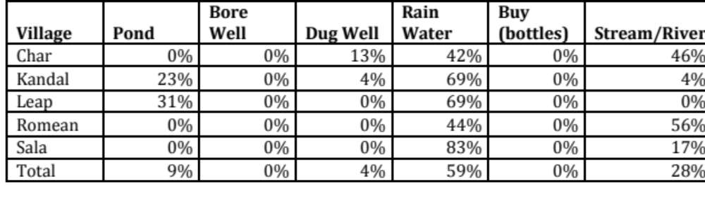

Figure 8 Main source of drinking water in dry season
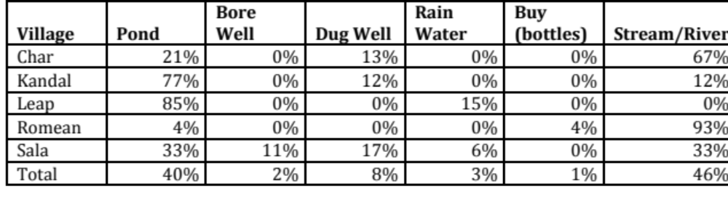

A total of 4% of households reported buying water in the wet season, with 25% purchasing in the dry season. The amount paid in wet season ranged between $0.75 per week and $6.25 per week, while during the wet season the amount ranged between $1.25 per week and $7.5 per week.

The time taken to walk to get household water on a daily basis is on average in wet season 23 minutes (round trip), and in dry season 44 minutes, primarily due to water sources drying out (Figure 9).

Figure 9 Minutes walking to water source, by season (round trip)
Village | Wet Season | Dry Season
Char | 16 | 45
Kandal | 19 | 46
Leap | 18 | 33
Romeat | 35 | 44
Sala | 12 | 46
Total | 23 | 44

  - Water storage

One hundred and five (105) households of 108 had drinking water storage containers of some sort, with the 63% percent covering all jars (Figure 10).

Figure 10 Percent of households covering all water storage jars
Village | Percent HHs with all jars/storage covered
Char | 63%
Kandal | 76%
Leap | 85%
Romeat | 44%
Sala | 56%
Total | 63%

Observation was done on the state of cleanliness of water storage jars in the household, with 43% having sediment inside, and 50% algae growth inside (Figure 11).

Figure 11 Level of cleanliness of water storage containers (n=105)

Fifty-five (55) percent of water scoops were visibly dirty upon inspection, and 25% used a method of getting water from the containers that could contaminate the water (hands directly touching the water or directly touching part of the scoop that goes in the water).

Seventy-three (88%) percent of households stored water to keep it clean/prevent contamination/keep it safe, while 45% stated it was to reduce travel time.

Overall, 33% of households treated drinking water in at least one way, ranging from 17% (Sala) to 46% (Leap).

Figure 12 Percent of households treating drinking water
Village | % HHs that treat their drinking water
Char | 25%
Kandal | 38%
Leap | 46%
Romeat | 41%
Sala | 17%
Total | 33%
Water treatment

The most common method of treatment is boiling water (Figure 13), with 31%. Overall, 1% of households in all five villages have a water filter.

Figure 13 Type of water treatment, by village
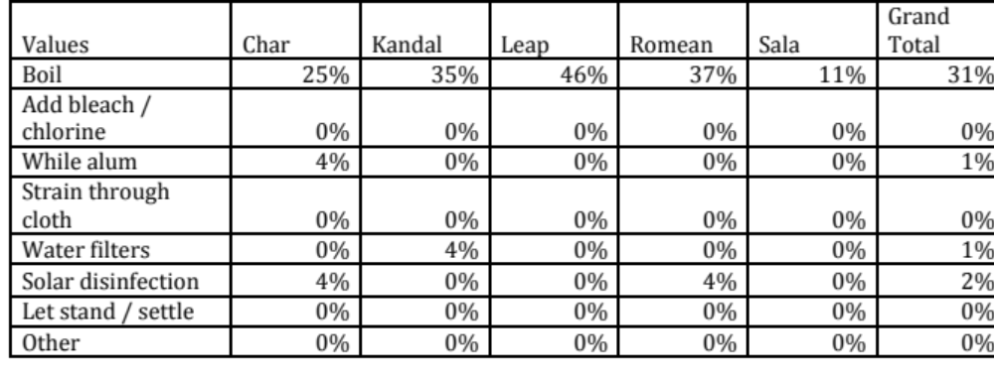

Of those who treat their water, 83% do so at all times. The most common reason for treating was to prevent illness (50%) (Figure 14).

Figure 14 Reasons households who treat their drinking water (n=36) do so

Those that treat water to prevent illness (n=18) treat primary to prevent diarrhea (89% of those treating household water for the primary reason of preventing illness), while 11% of the same sample treat for other reasons. No respondents specified treating to avoid urinary tract / kidney infections

Households that treat drinking water have a lower rate of diarrhea than compared to the total survey population (Figure 15). The overall number of households reporting diarrhea in the last two weeks was 45%, while 33% of those who treat water reported diarrhea in the last two weeks.

Figure 15 Percent of HH respondents the have had diarrhea comparing all HH with HH that treat drinking water
 | treat water | overall HH
have diarrhea | 33% | 43%

Three of the five villages had water filters, with only 7% of households having them in the village of highest coverage (Romeat, 7%). Half used them and half did not (due to blocked and broken filters).

Figure 16 Percent of households with water filters
Village | % of HHs with water filters
Char | 0%
Kandal | 8%
Leap | 0%
Romeat | 7%
Sala | 6%
Total | 5%

Washing hands before eating is very common (over 90%), however hand-washing after defecation and before preparing food is low (about 20% each) (Figure 17).

Figure 17 Key times for hand-washing

The number of respondents reporting using water and soap is high (up to 71%) (Figure 18). However, neither water nor soap is likely available when defecation outdoors takes place (as it is often away from the house), and lack of a fixed hand-washing place means hands are often washed with the drinking water supply, which can get contaminated when hands (or scoop) are dipped in.

Figure 18 Percent of respondents washing with water only and water and soap
Village | Water only | Water and soap
Char | 25% | 71%
Kandal | 38% | 58%
Leap | 31% | 69%
Romeat | 37% | 63%
Sala | 56% | 44%
Total | 38% | 63%

Households that had a fixed place to wash hands varied between 6% (Sala) and 21% (Char). For households without a fixed hand-washing place, most used their water storage jugs to wash with.

Use of soap at fixed hand-washing stations is high (ranging from 67% to 100%), although the total number of households with both a fixed hand-washing station and soap is low (Figure 19) (numbers reflect more of a situation of lack of fixed hand-washing stations rather than lack of soap).

Figure 19 Percent of HH with fixed hand-washing stations that have soap (n=14)
Village | % of fixed hand-washing stations with soap
Char | 4%
Kandal | 3%
Leap | 2%
Romeat | 3%
Sala | 1%
Total | 2%

About 80% of households reported washing hands prevents disease or removes germs, while just under 30% specifically mentioned it prevents diarrhea (Figure 20).

Figure 20 Importance of hand-washing

- Latrine Access and Sanitation

Percent of households that had a latrine that was in use ranged from 0% to 3% (Figure 21) Interviews with village chiefs indicated villages had 15-35 latrines (Annex 2); most of these latrines are new and construction has not been completed. While one household indicated they do not use theirs as there is not enough water for cleaning themselves/flushing, the primary reason for those with latrines indicating they are not in use is 10 households have been recently supplied with the materials for construction but have not yet completed construction. Fourteen (14) percent of families share their latrine with other households.

Figure 21 Percent of households that have a latrine that is used
Village | % HH that have a latrine that is used
Char | 0%
Kandal | 3%
Leap | 2%
Romeat | 0%
Sala | 3%
Grand Total | 1%

The most common method for dealing with a full latrine is to build a new one (Figure 22). Of those that empty their latrine, they use it as fertilizer or empty the contents into a new hole (although some respondents who have not emptied mentioned they would dispose of the contents in the forest or in a river/pond/stream). If the latrine breaks, 47% responded they would fix it, 16% would build a new one, and 5% would revert to defecating outdoors.

Figure 22 Methods of dealing with full latrine (n=21)
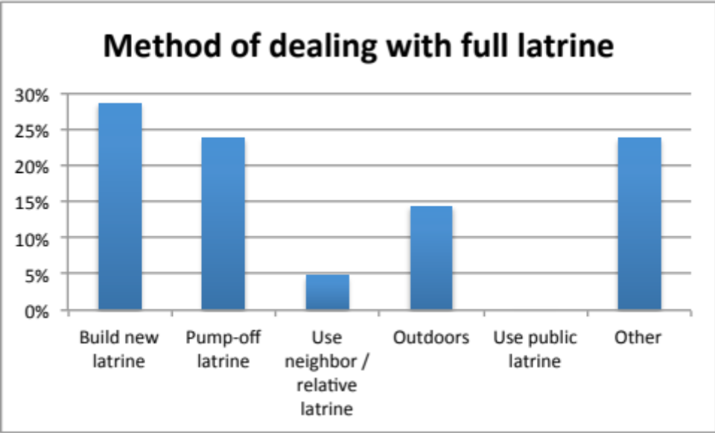

Of those that had latrines in use, 50% for Leap and 50% from Sala experiences flooded last year (cases of 0% reflect lack of respondents with latrines in use rather than lack of flooding the locations) (Figure 23).

Figure 23 Latrine flooding situation
Village | Percent of latrines that flooded last year
Char | 0%
Kandal | 0%
Leap | 50%
Romeat | 0%
Sala | 50%
Weighted Average | 19%
When asked about the primary location of defecation, 89% reported going outdoors (ground/forest), while 7% went in their own latrine (Figure 24). Sixty-nine (69) percent who go outside always bury their feces. Defecation from the main source of drinking water was on average over 500 meters away, although 23% reported defecating within 50 m of a water source, with individual reports of 2-3 meters away, and one in the water source (Sala).

Figure 24 Location of defecation
Location of defecation | % HH
Outdoors (ground/forest) | 89%
In own Latrine | 7%
In neighbor latrine | 1%
In yard / garden | 1%
In neighbor's yard / garden | 1%

Infant feces is usually disposed of through burying (61%), followed by throwing in the forest (33%). Only 2% reported throwing in water sources.

The main advantages seen in owning a latrine is to improve hygiene, followed by improving safely (Figure 25).

Figure 25 Household perception of advantages of latrines

When asked how villagers could be encouraged to build and use latrines, the most common thought was that provision of materials would be useful (over 60%). On average, villagers are willing to contribute roughly $50 towards the costs of a latrine. Multiple people in the village paid $62 for latrines recently, thus willingness to pay can be demonstrated.

Figure 26 Encouraging latrines in villages

- Health and Social Impacts

The survey had a fair focus on diarrhea, as well as urinary tract / kidney infections (which were identified in a pre-survey visit by the commune chief as issues). An open question was asked on ‘what is the biggest health issue in your family; this was asked as the beginning before specific questions so as not to create a leading question.

Combined, over 50% of households said their biggest health problem was either gastro-intestinal tract problems (G.I. tract – referred to in the survey as ‘stomach problems’) or diarrhea (Figure 27). Fever affected almost 10% of households. Two households with diarrhea and one with fever reported vomiting as an additional symptom. Typhoid, tuberculosis (TB), dizziness, colds, and lung problems affected roughly 4% of households.

Figure 27 Main health issue faced by household; N-108

Overall, the percent of people (belonging to respondent households) with diarrhea is 12% (Figure 28), and with urinary tract infections 4%. Sala had the highest rate of diarrhea. Leap had a much higher rate of urinary tract infections than the other villages, at 13%.

Figure 28 Rates of diarrhea and urinary tract infections (last two weeks) (total of all households’ members of respondents)
Village | % with diarrhea | % with urinary tract infections
Char | 14% | 5%
Kandal | 11% | 4%
Leap | 9% | 13%
Romeat | 11% | 2%
Sala | 15% | 3%
Total | 12% | 4%

Children missed an average of 2 days of school due to diarrhea / urinary tract infections (Figure 29), while adults missed an average of 4 days (Figure 30).
Respondents had difficulty with recall and actual numbers may be higher.

Figure 29 Average number of days children miss school for diarrhea / urinary tract infections
Village | average days child/ren missed school per child
Char | 3
Kandal | 1
Leap | 0
Romeat | 1
Sala | 4
Grand Total | 2

Figure 30 Average number of days adults miss work for diarrhea / urinary tract infections
Village | average days missed per adult
Char | 11
Kandal | 1
Leap | 3
Romeat | 1
Sala | 4
Grand Total | 4

In Char, 75% of households received medical attention in the last year for diarrhea / urinary tract infections, while the other villages ranges between 39% and 53% (

Figure 31).

Figure 31 Medical attention for diarrhea / urinary tract infections

Expenses for diarrhea / urinary tract infection related treatment (including transport and medicine) averaged $162, plus an additional $20 for transportation.

Figure 32 Average spending on treating urinary tract infections and diarrhea in last 12 months
 | $ doctors/  medicine | $ transport | $ total
Char | 119 | 14 | 133
Kandal | 51 | 15 | 67
Leap | 181 | 21 | 202
Romeat | 145 | 18 | 163
Sala | 63 | 49 | 112
Grand Total | 108 | 20 | 128

Of those that did not receive medical attention, 19% felt it was not bad enough to warrant it, 6% did not have enough money, 7% felt it was too far away, and 1% didn’t think treatment would help.

Over 65% of households believe treating drinking water will prevent diarrhea. While 35% believe hand-washing if effective (

Figure 33).

Figure 33 Prevention of diarrhea

- Discussion and recommendations

Water access and contamination

Access to clean water is particularly scarce in dry season, when rainwater no longer becomes an option. Travel time ranges from a half hour to one hour per day for water transport, with only 17% of households treating drinking water (primarily through boiling). Sixty-three (63)% have all water storage covered. Water filter use is very limited (5%). Hand-washing before eating is very common (over 90%), but after defection and before food preparation is poor (about 20% each). Respondent use on washing with soap is high, however actual observation of the access of a fixed washing area and available soap resources does not match up (there are few fixed hand-washing places; people tend to wash at the water storage area; those that do have fixed hand-washing areas tend to have soap). In addition, most people defecate outdoors where there are no hand-washing facilities. Those that have fixed hand-washing stations usually have soap there (93%).

Recommendations:

- Water filter coverage is very low, with no known other groups involved in the area; water distribution beneficial to all potential coverage area
- Hand-washing: very low hand-washing after defecation and before food preparation; combination of understanding key hand-washing times along with access to hand-washing (fixed facilities, hand-washing separate from stored water, access to soap at all times); latrines on site will better facilitate hand-washing than going in a remote location.
- Encourage fixed hand-washing stations separate from stored/drinking water
- Wells: high feedback for bore wells

Target Locations

- Water filter – all areas; specific requests from village chiefs of Romeat and Sala (Char not asked)
- Wells – Char, Romeat and Kandal have no wells (Leap has 1 dug well, Sala 3 dug and 3 drilled wells); specific requests from the village chiefs of Romeat, Kandal, Leab (Char not asked)

Latrine Access and sanitation

It is felt by the majority of respondents (over 50%) owning a latrine improves hygiene, and over 40% feel it would improve safety. The benefits of owning a latrine are understood, as is the will to contribute labour and money. Multiple respondents have contributed to the latrine they currently have under construction, and the survey indicated households are willing to pay on average $50 for a latrine.

Recommendations

- Latrine coverage: operational latrine coverage is low; all villages would benefit from additional operational latrines, however there are a number in each village either under construction or needing repair (between 15 and 35 per village according to the village chiefs);
- it should be double-checked what the current distribution plan and method is to avoid repetition, ensure an approach that will complement the current approach, and if there are bottlenecks to the current method, the reasons are understood (eg lack of labour due to seasonal harvest/migration, lack of additional materials, lack of knowledge, not enough time to implement); in addition if latrines are no longer functional, it should be ensured that this can also be avoided in the future
- Public latrines are not a feasible option (no interest), although it is not uncommon for households to share with neighboring households
- Latrines provided for school (male and female) (would also need a well for flushing /cleaning)
- Provision of materials is the method respondents felt would most encourage others to build a latrine

Target Locations

- Latrine: Kandal and Romeat have lowest coverage according the HH survey; specific latrine requests from village chiefs from Romeat, Kanda, and Leab (Char not asked)
- Flood: flooded latrines were an issue in Char, Leap, and Sala, although any latrine implementation in the other two villages should take possible flooding into account

Health and social impacts

The biggest health issue faced by families (more than 50%) is gastro-intestinal problems and diarrhea. An average of 12% had diarrhea at the time of the survey, and 4% urinary tract/kidney infections. Medical expenses can carry a clear burden on household income, with average spending of over $100 per household (that received treatment for diarrhea and urinary tract infections), and depending on the village, the nearest health clinic is 24-42 km away. While cost and distance has prevented some from seeking treatment, households are more likely to seek treatment and bear the costs. Understanding of the importance of treating drinking water to prevent diarrhea is high (over 60%), although the percent who boil or otherwise treat their water in practice is lower.

Recommendations
- Indirect reduction of expenses through treatment of source of diarrhea (addressed in objectives 1 & 2)
- Direct reduction of expenses through means of medical support / treatment assistance (eg health insurance, voucher system…) (dependent on feasibility of partnership implementation and final direction of project design)

Target Locations
- Those chosen for objective 1&2

Annex 1 – Village level demographics

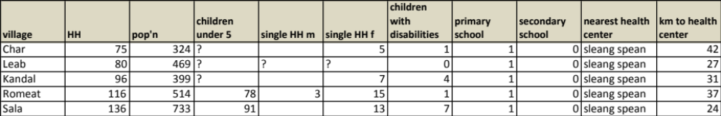

Annex 2 – Village water source, well, filter and latrine situation; critical needs and improvements needed

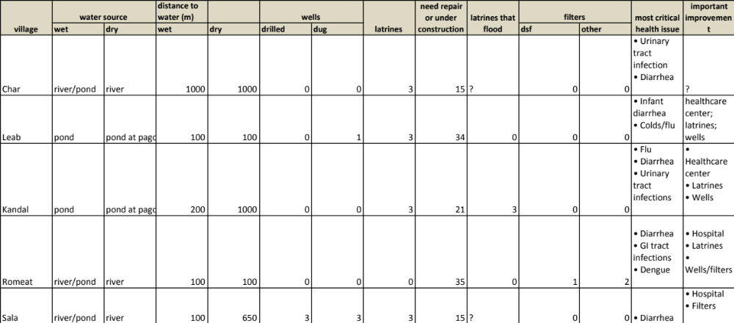

Annex 3 – IDPoor by Village (Survey Respondents)

 | IDPoor 1 | IDPoor 2 | Not IDPoor
Char | 38% | 17% | 46%
Kandal | 23% | 15% | 62%
Leap | 31% | 15% | 54%
Romean | 11% | 11% | 78%
Sala | 17% | 22% | 61%
Grand Total | 23% | 16% | 61%

Additional Notes from Village Chief Information
- Kandal Village Chief reports 7/10 years pond dried up

Numbers reflect more of a lack of fixed hand-washing stations than lack of soap
cases of 0% are due to sample size being zero, rather than lack of flooding
Absolute numbers here are very low, with 1 to 2 households surveyed per village having one, and no more than three in all villages surveyed operational.
Results in Char are high as two respondents reported missing 90 and 120 days of work respectively. Only 6 respondents missed more than 10 days of work in total (all villages), with most missing between 1 and 5.
One household reported over $2000 in medical expenses for a combination of symptoms, including malaria and a collapsed lung

